OOAD LAB EXPERIMENTS **DAY-2**

**11.AIM:-**

To develop a system using UML for Conference management system.

UML DESIGNS:-

1.USE CASE:

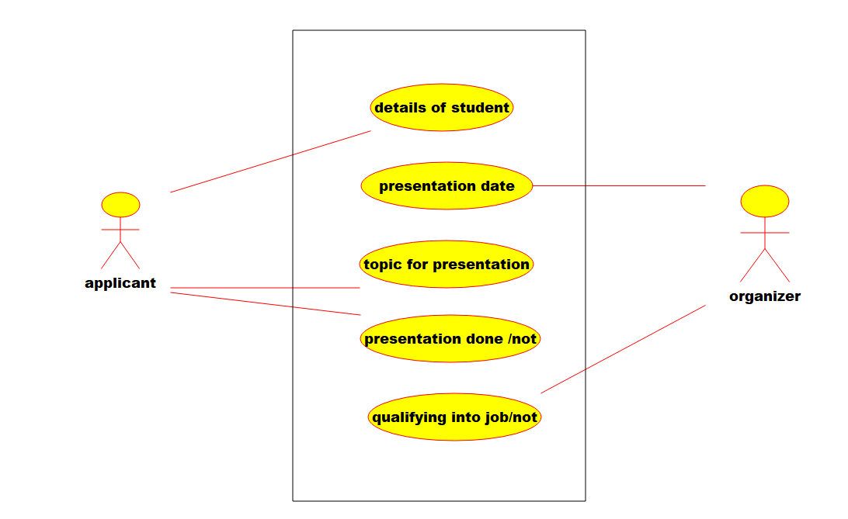

2.Deployment:

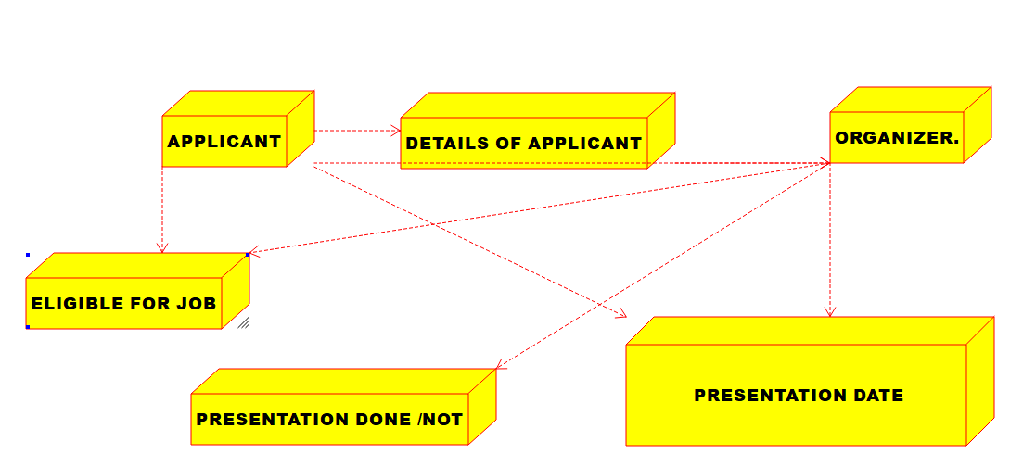

3.PACAKAGE:

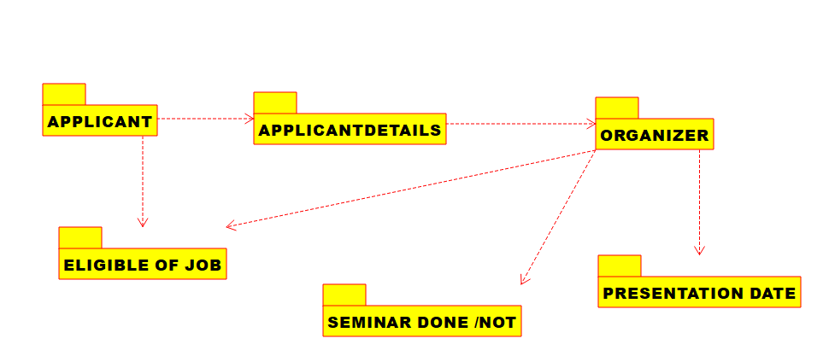

**12.AIM:-**

To develop a system using UML for Foreign Trading System.

UML DESIGNS:-

1.SEQUENCE DIAGRAM:

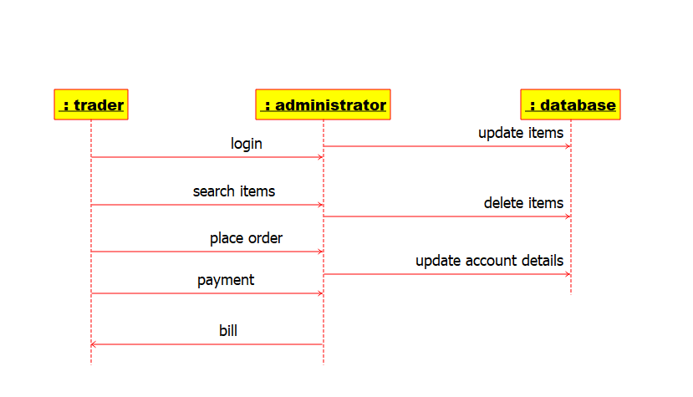

2.ACTIVITY DIAGRAM:

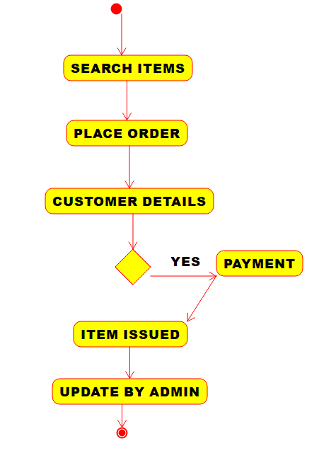

3.COMPONENT DIAGRAM:

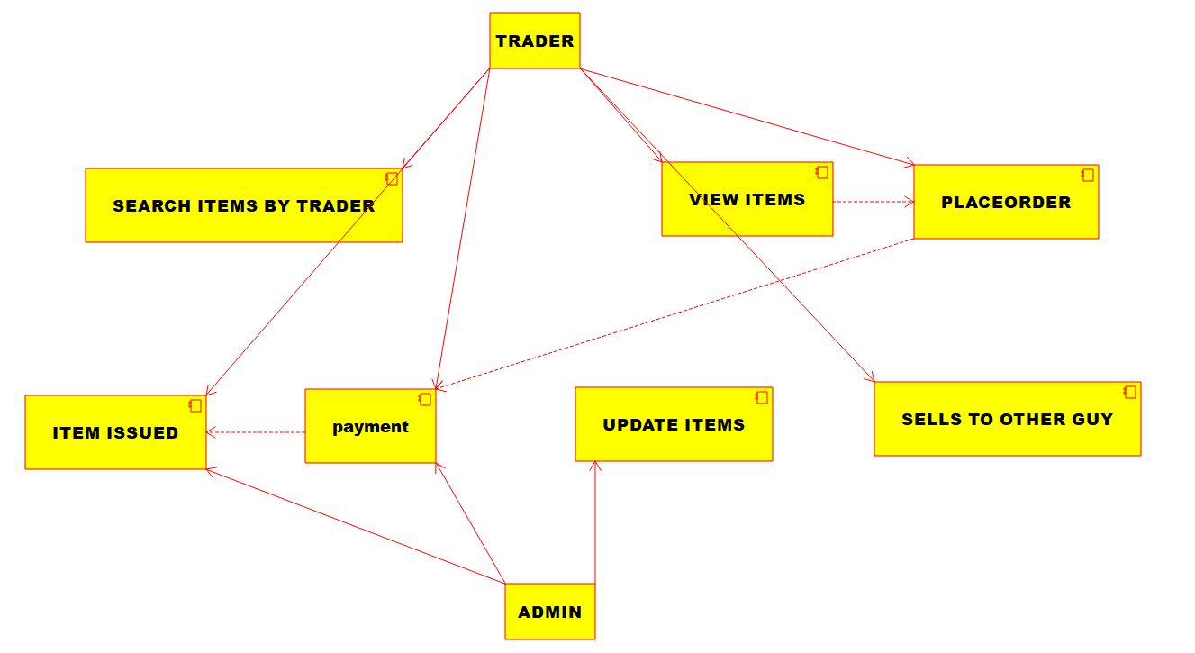

**13.AIM:-**

To develop a system using UML for BPO Management System.

UML DESIGNS:-

1.ACTIVITY:

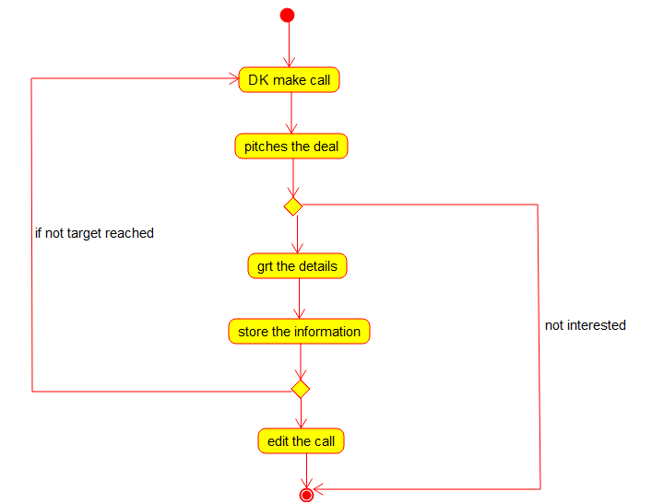

2.STATECHART:

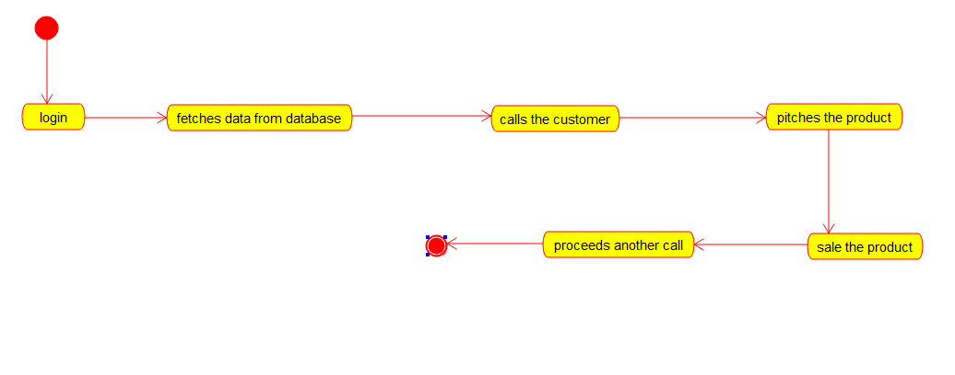

3.CLASS DIAGRAM:

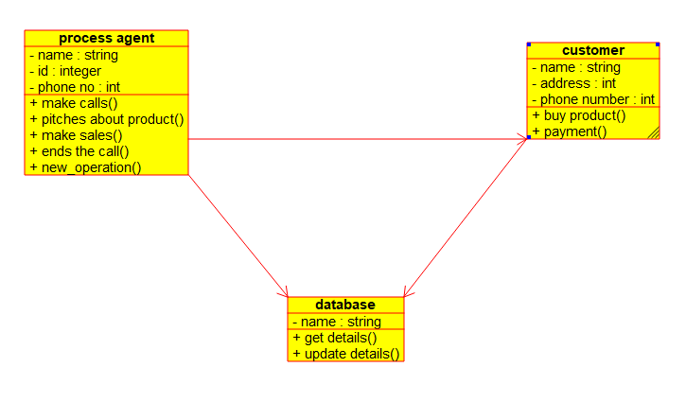

**14.AIM:-**

To develop a system using UML for E-Commerce Registration.

UML DESIGNS:-

1.ACTIVITY :

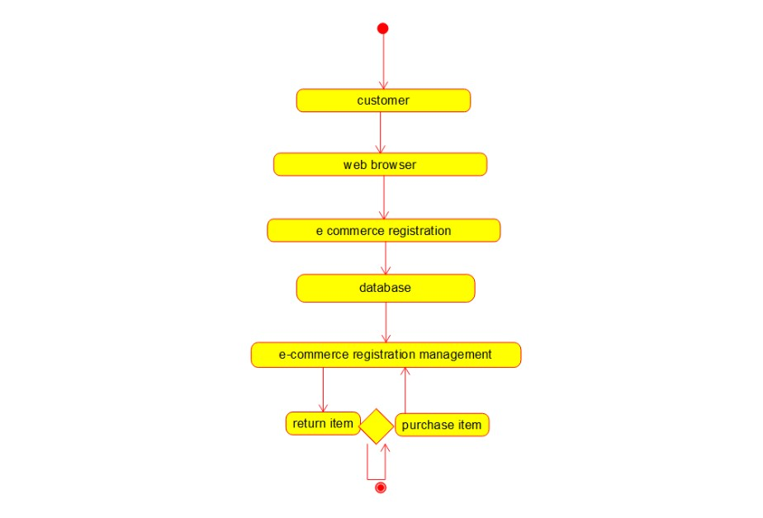

2.SEQUENCE:

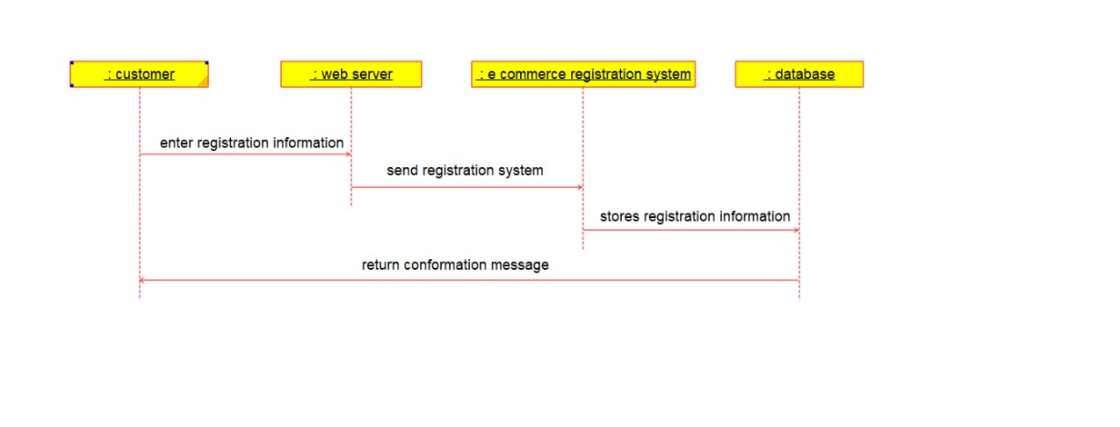

3.PACAKAGE:

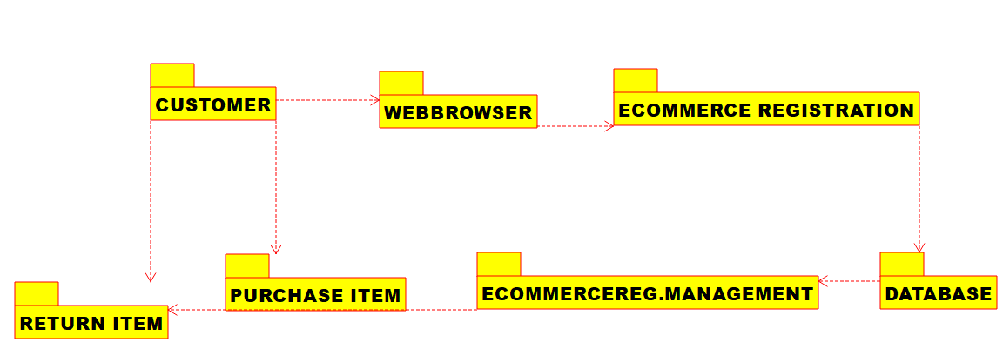

**15.AIM:-**

To develop a system using UML diagrams for Blood Bank Registration System.

UML DESIGNS:-

1.USE CASE:

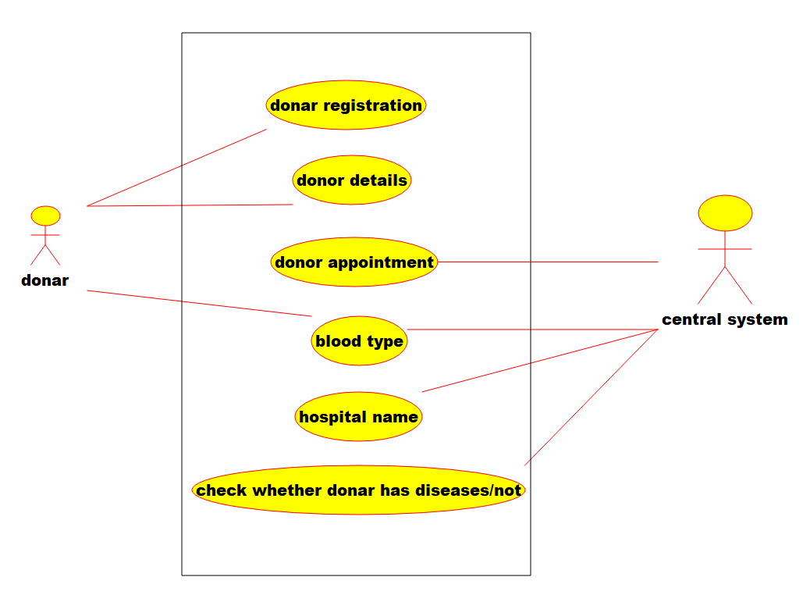

2.COLLABORATION:

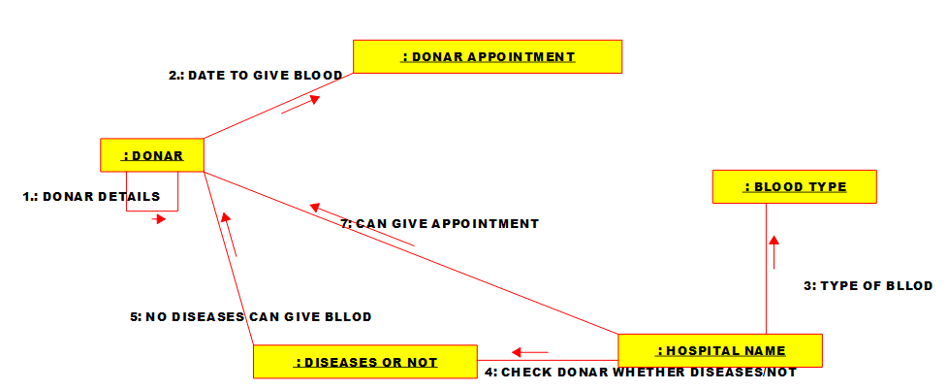

3.STATECHART:

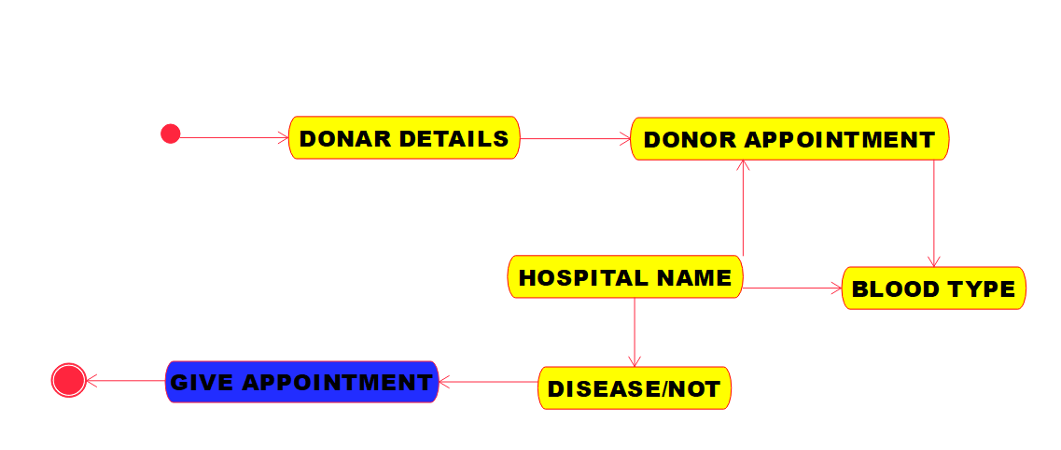

**16.AIM:-**

To develop a system using UML for Online Internship Registration System.

UML DESIGN:-

1.COMPONENT:

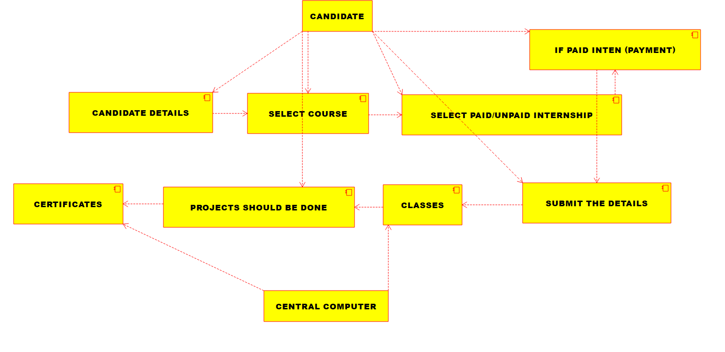

2.Deployment:

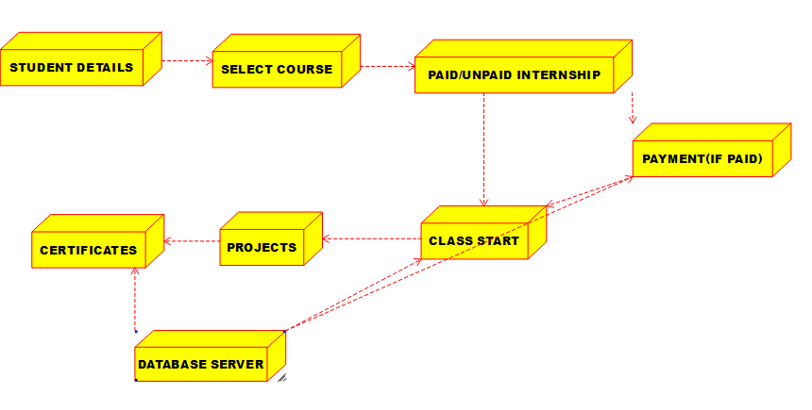

3.ACTIVITY:

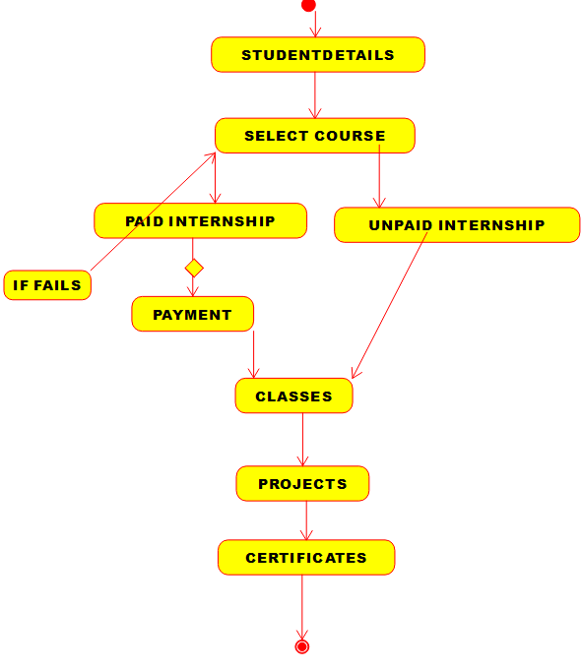

**17.AIM:-**

To develop a system using UML for Vehicle Registration Number Registering System.

UML DESIGNS:-

1.SEQUENCE:

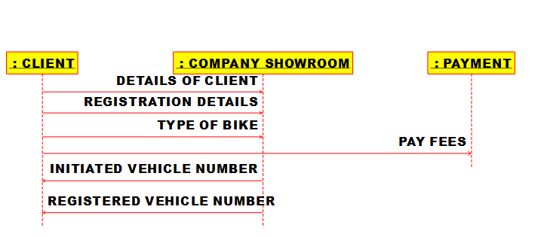

2.CLASS DIAGRAM:

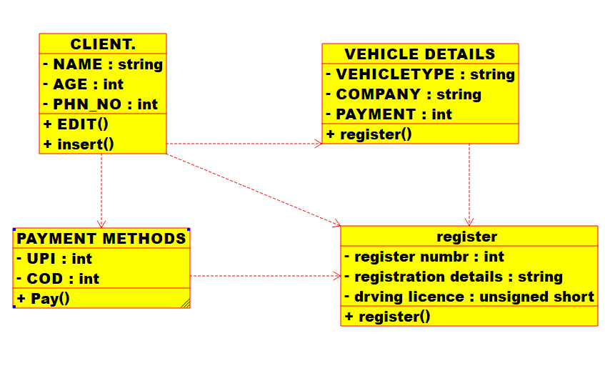

3.PACAKAGE DIAGRAM:

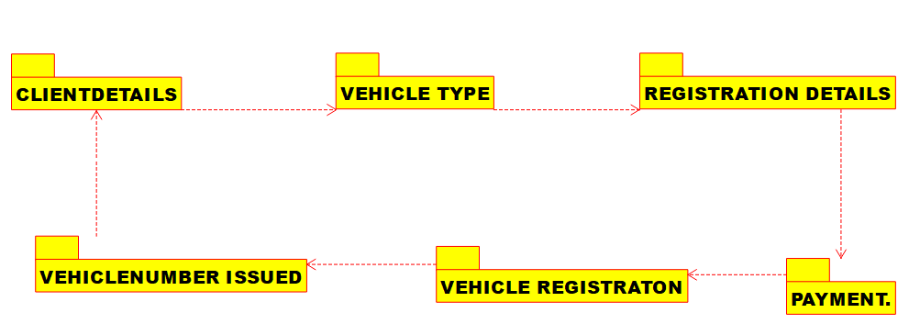

**18.AIM:-**

To develop a system using UML for FOOD ORDERING System.

UML DESIGNS:-

1.USE CASE:

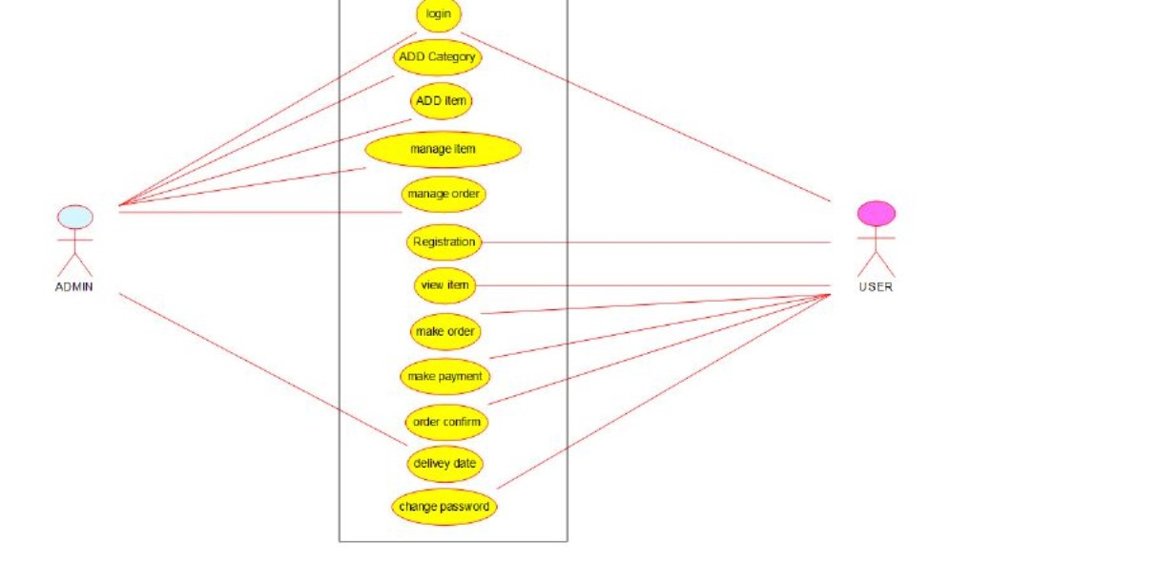

2.CLASS: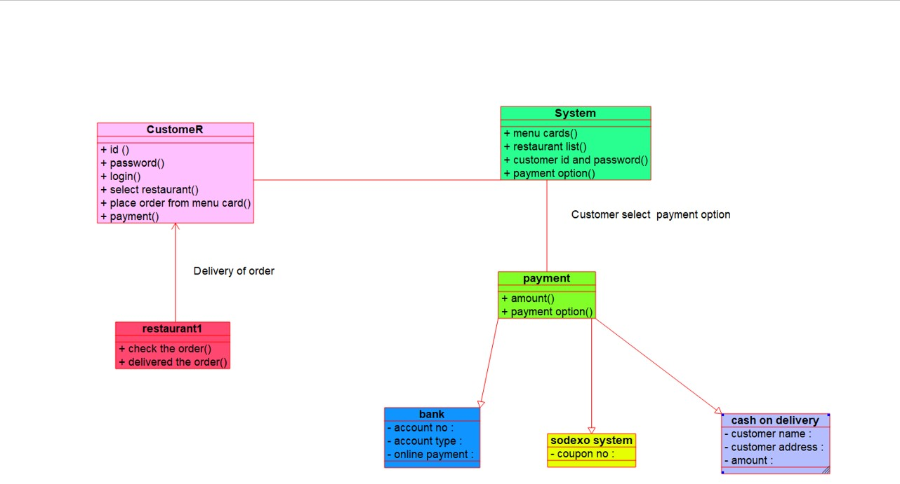

3.COLLABORATION:

